**Supplementary Figure 1**: *Proposed model how glycolysis via* ***Hexokinase*** *(HK) affect SARS-CoV 2 replication and other metabolic changes. Ligand binding ability of potential drug 1,8 Cineole to HK is also shown. SARS-CoV-2 infection augments glycolysis by unusual production of mitochondrial ROS which leads to activation of transcription factor hypoxia-inducible factor-1α (HIF-1α) to safeguard its rapid replication. This increased glucose metabolism by aerobic glycolysis nurtures viral replication and cytokine production conceding T-cell response and function as well as induces lung epithelial cell death.*

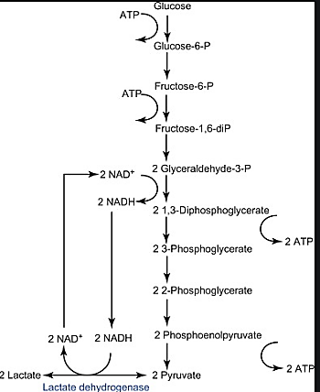

**Hexokinase (HK)**

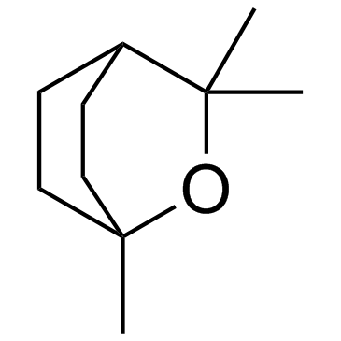

**Eucalyptol, 1,8 Cineole**

**Glycolysis**

**ROS**

**Impaired oxidative phosphorylation**

**HIF 1α**

**Glycolytic genes**

**(+)**

**SARS-CoV 2**

**Replication**

**Cytokine storm**

**Epithelial cell death**